Week 19 Project Plan

Team Identifier: T13Hide Studio Number: Studio 13

# Section 1: Gantt Chart

Gantt chart from instructor review pre-changes.


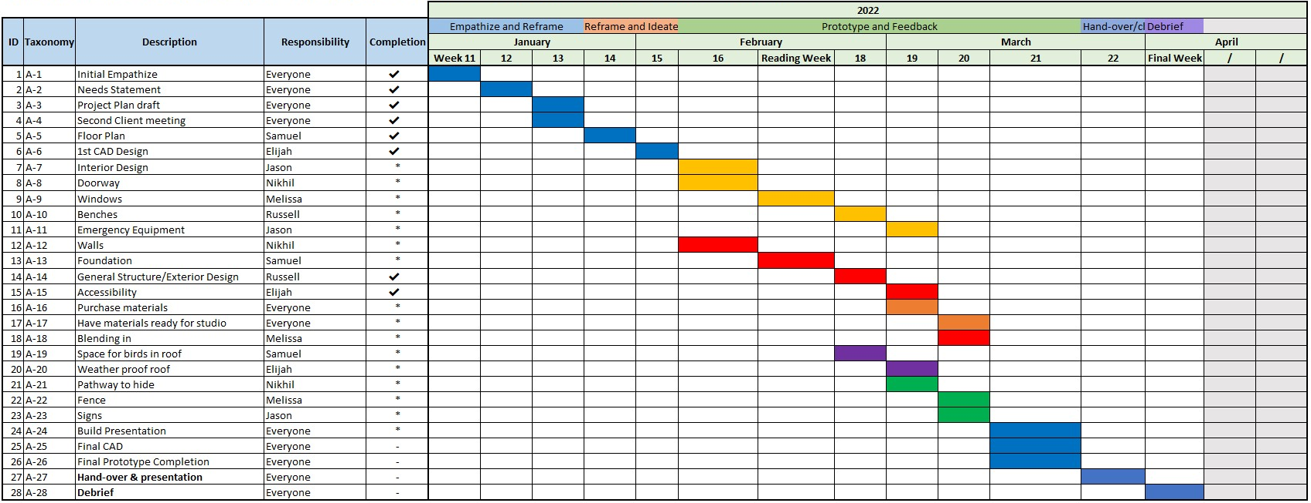Figure 1: Old Gantt Chart from Week 16 Instructor Review

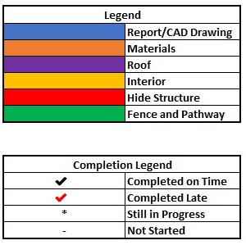Figure 2: New Gantt Chart with Updates

Figure 3: Some of the Updated Areas

*Discussion of Highlighted Sections:*

Three major changes between our Gantt chart from week 16 and our present chart can be seen highlighted above in Figure 3. While there were multiple other small changes made throughout the chart these were the ones determined to have the most significant effect on both our future productivity and improving our documentation of the design process.

The left most image is a closer look at the legend which describes the colour scheme used through the chart to aid in visual separation of the different stages through which the design will proceed. There is also a completion column, and the legend differentiates the different symbols used to show if the item was completed on time, is in progress, has not been started, or is completed late. These are both particularly useful when checking to see if all the necessary work for a part of the design is completed. Someone can look for the relevant section in the legend and quickly scan for that colour to determine who was meant to do the work, when it was meant to be finished, as well as the status on completion. This is a major improvement over our original chart as the colour codes would be useless to anyone who was not present when it was created and could also lose its effectiveness as we gradually forget our original intentions for them.

The center image highlights the creation of the responsibility’s column and some of the first entries into the section. While many of the sections in our chart include contributions from all or most of our group members, hence the “everyone” tag, there are also many individual responsibilities that were distributed amongst group members. This is a more efficient method than only using the meeting minutes to assign roles as it keeps all the assignments together in one place which can be easily referenced by members of our team.

The right most image focuses on a small subset of the items listed in our Gantt chart. The significant items in this section are “Purchase Materials” and “Have Materials Ready for Studio”. We found later into the project that there were a few items we had not previously considered when creating our chart. These items have been sprinkled in throughout providing a more comprehensive and complete evolution of our design.

# Section 2: Project Scope

Figure 4: Scope Venn Diagram

In general, we have changed our scope by increasing the detail in all three sections. This change is most pronounced in the non-scope section, where we’ve doubled the number of elements present there. These new elements are essentially just composed of items which the clients stated *they would have to do*, which thus implied was not to be performed by us. Most of these things were intuitively not relevant for the project, but their actual inclusion in the scope was more prompted by the client’s words in the meetings, or by reflection by us. For instance, ‘securing funding for the hide’ was one item which the clients talked about at length, saying that this was something that the NCC (Nature Conservancy of Canada) itself had to do. On the other hand, ‘creating the parking lot, trails, signage...’ was an element which we ourselves intuited. In the overlap section, the ‘finding suppliers’ element was similarly developed by us through our own consideration. It has recently been brought to our attention that creating a materials list for our actual design would be a good idea; one which could be used by the clients to construct it. But it’s key to keep in mind that any such list should be general in character, so that it can be modified at the clients’ leisure. The main takeaway from our analysis of the project scope is what our actual role is in this project. We are not building the hide, we do not need to worry about the logistics of securing funding or materials for construction, we do not need to worry about getting the word out about the hide. In this case, we are first and foremost designers. This means we can focus our energy on creativity and providing our client with a list of innovative features to choose from. Our primary concern should be with designing the best hide which can then have features removed to fit the clients liking and budgetary limitations. The scope of this project is in creatively designing an enjoyable space for all to watch nature.

Section 3: Risk Analysis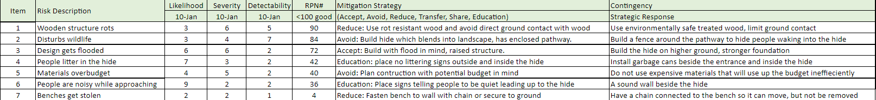

Figure 5: Risk Analysis Chart

The biggest risk, as seen through our risk analysis, is the potential of the many different wooden parts of the structure rotting. With a key feature of the hide being its ability to blend into the environment and not disturb wildlife during construction, maintenance, or presence, wood is the best material to use. Peelee island is a damp location with plenty of seasonal wear and tear from rain, frost, and snow and as such the wood will experience high levels of water damage if the proper measures are not taken in planning and construction. There are many ways we can mitigate this risk. Firstly, by choosing a location away from any bodies of water, there is a significantly less amount of moisture in the soil and from rainfall. While the exact location is outside of our control, we can limit the contact to flood water and ground moisture by raising the structure off the ground on stilts. To limit how moisture will impact wood, we will use many strategies to prolong the life of the hide. Using environmentally friendly chemically treated wood, aluminium caps on the end of wood planks, a less rot prone wood like cedar, and adding ventilation spaces where two surfaces meet.

A close second to this primary risk is the hide disturbing the surrounding wildlife. The primary expected causes of this risk would be from the sounds of people approaching, loss of habitat, and littering. To mitigate this risk, we will implement solutions for the multiple ways in which wildlife could be disturbed. To lower noise pollution a sound wall will be placed near the entrance in addition to signs reminding people to lower their voices as they approach. While the loss of habitat is unavoidable, we will try to give back some of that space with nature friendly design features such as a raised roof which will have bird/bat cups and boxes to promote roosting in the roof as well as space underneath the hide which could become home to small animals like snakes and frogs. Littering will hopefully be reduced through the placement of animal resistant garbage cans in convenient locations as well as signage reminding people to put trash where it belongs, and the location of the nearest garbage can. A final serious risk is the hide becoming flooded in the warmer seasons as the area that the hide is planned to be on has experienced mild flooding in the past. To help mitigate this risk two primary design elements will be included. Firstly, the hide will be raised off the ground to hopefully avoid the problem in the first place. As a second contingency the hide will have holes and slight slope to ensure water will drain out naturally as flood waters recede in addition to keeping the elements most susceptible to flooding higher up.

# Section 4: Summary/Reflection

The tool that was most important and useful to our design process and project was our Gantt chart. We knew early on that some form of a schedule would be necessary if we wanted to stay on schedule with our project timeline. We had a wide range of options to choose from including timelines, calendar notifications, and Gantt charts. We settled on using a Gantt chart due to the numerous advantages it provides over other more typical project management tools. Some of these advantages include the ease in seeing the project progress by following the linear trail, the clarity provided by a visual representation of the evolution of the project, and the ability to section off different ideas while keeping them a part of the main structure through the use of colour. These were important considerations for our team, especially with the virtual start, as we had one location team members could quickly reference and decide whether they were on track for completing their deliverables to not fall behind on the schedule. We also could transfer over the responsibilities assigned in meetings and minute action items to the master Gantt chart to ensure everyone is aware of their assigned work without needing to search through meeting minutes for a specific task. Through multiple iterations our Gantt chart improved to be more visually effective and can now be easily used by someone unfamiliar with our project allowing for easy demonstration of our process to other people.

The Gannt chart has helped our team stay organized and delegate tasks on various occasions. One specific instance where the Gannt chart aided the progression of our work was when we were on reading week. During reading week, we had a few tasks to complete to prepare for week 18, these tasks included the interior design components that will be included within the hide. The Gannt chart helped us delegate tasks before the reading break, so that once we got back to in person, we could see the work that got completed by each group member and decide what the next steps were. The chart has allowed us to plan all our project elements in advance so that we do not need to worry about what component needs to be completed next. This has been extremely beneficial especially since we started this semester online, and it was difficult to meet with our team, therefore we would be doing a lot of the work independently. It was easy to see who was getting what task completed and when the task needed to be completed by during virtual learning. The chart also carried over so that when we came back to meet in person the transition of our workflow was very smooth. Overall, this chart has significantly helped our team stay focused on the most important project tasks and holds each group member accountable for their action items.